**What is a Whole Grain?**

Whole grains contain three parts of the grain: germ, bran and endosperm. Refined grains, like white bread or white rice only contain the endosperm.

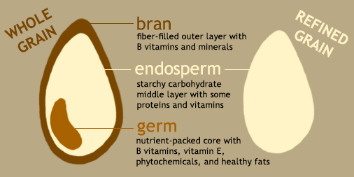The bran and the germ of the grain contain fiber, B-vitamins, minerals antioxidants (like vitamin E) and healthy fats. When a grain is refined, the bran and the germ are removed, leaving very little fiber and a few of the naturally occurring vitamins and minerals.

Refined grains are fortified with a plethora of vitamins and minerals, like vitamins A & C, folic acid, calcium and thiamin. Fiber on the other hand, along with the healthy fats, are not added back into the refined grains.

**What Grains Are Whole?**

Listed below are a variety of whole grains with a brief description…

**Amaranth**- high in protein and fiber, can be used as a cereal grain or as a flour. Has a nutty flavor.

**Barley**- A cereal grain with a chewy texture, opt for hulled barley instead of pearled barley, as the bran has been removed in pearled barley.

**Brown** **Rice**- Similar to white rice except it still has its bran and germ intact, giving it its brown color.

**Buckwheat**- Buckwheat is actually a seed, but it can and is used like a whole grain. Can be made into flour for various products, such as breads, noodles and cereals.

**Bulgur**- This is a cracked wheat berry that is partially cooked and dried before packaged. It is most commonly used in tabouli (tabbouleh).

**Millet**- This whole grain resembles tiny corn kernels and is very cheap. Has more of a sweeter taste, comparable to corn. Can be used as a substitute for rice.

**Quinoa**-Quinoa has gained popularity in recent years and for a good reason. This grain is high in protein, fiber and is easy to cook!

**Rye**- A cereal grain, similar to wheat, this whole grain packs a hearty flavor. The darker the rye bread, the better for you!

**Oats**- A very versatile cereal grain that most of us are familiar with. When making oatmeal for breakfast, try to cook from scratch rather than using the packets of instant oatmeal.

**Wheat** **Berries**- These are whole kernel wheat grains. These can take some time to cook due to their bran, but are excellent in soups, chili or in any recipe that requires rice.

**How Much Whole Grains is Enough?**

The Dietary Guidelines for Americans (DGA) recommends to make at least half of your grains whole grains throughout the day. While most Americans meet the recommendation for grain intake, a whopping **98%** of Americans do not meet the recommendations for *whole grain* intakes. On top of that, 74% of Americans exceed the recommended intake for refined grains, with about 20% of all refined grain intakes coming from concentrated sweets and snacks, like cookies, pretzels, cakes, crackers etc…

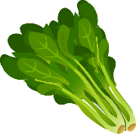If most, to all, of your grain intakes comes from whole grains, you will want to make sure you are getting enough folic acid in your diet. One of the most important contributors to dietary folic acid is enriched grain products, however there are plenty of natural foods that contain folate as well. Some foods that are good sources of folate are; dark leafy greens, fruits, nuts, beans, eggs and dairy.

*Source:* [*https://www.nih.gov/*](https://www.nih.gov/)

[*https://www.dietaryguidelines.gov/sites/default/files/2020-12/Dietary_Guidelines_for_Americans_2020-2025.pdf*](https://www.dietaryguidelines.gov/sites/default/files/2020-12/Dietary_Guidelines_for_Americans_2020-2025.pdf)